MEDIA RELEASE

Highland Falls Library Presents The Appalachian Trail – Fort Montgomery Project: Portraits of Thru Hikers on the Appalachian Trail

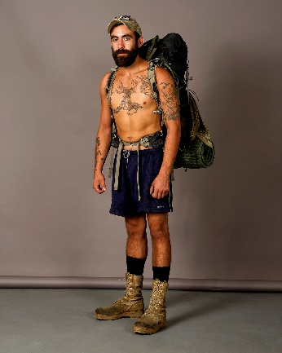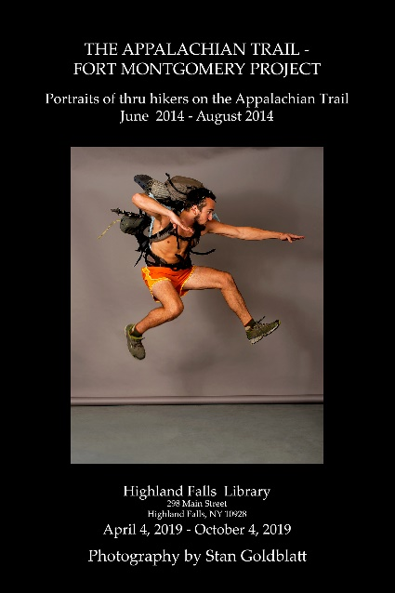

On View Location
April 4, 2019 – October 4, 2019 Highland Falls Library 298 Main Street Highland Falls, NY

HIGHLAND FALLS, NY (MARCH 2019) -- The Highland Falls Library proudly presents an exhibit by photographer Stan Goldblatt: The Appalachian Trail – Fort Montgomery Project: Portraits of Thru Hikers on the Appalachian Trail opening on April 4, 2019 through October 4, 2019.

About the Artist
Stan Goldblatt has lived in Fort Montgomery for over 45 years. He has provided photography for corporate clients including Xerox, Lederle Laboratories, American Express, Mercedes-Benz and BMW of North America. He has had his work published in Yachting Magazine, M Magazine, W Magazine, Women’s Wear Daily, Cruising World, Orange Magazine and The New York Times. He has provided performance and press photos for The Orange County Ballet Theatre.

Stan’s motivation for this project began after seeing AT thru hikers each year, starting sometime in June, showing up at the Fort Montgomery (NY) Post Office to pick up food drops. Earlier in his life, before three knee surgeries, Stan did a lot of backpacking, making him attracted to their journey. Seeing them repeatedly made Stan realize that studio portraits of the hikers would be a great photography project.

Stan said, “My plan was to meet them at Bear Mountain State Park by Hessian Lake with my dog, and convince them to come with me for a set of professionally-done portraits accompanied by chili and very cold drinks. I had hoped to get maybe 50 to come with me. In the end I photographed 166 hikers - the youngest hiker was 8 years old and the oldest was 66 years old.”

About the Exhibit
Twenty black-framed portraits (16”x20”) are on display in the Community Room of the Highland Falls Library. Each portrait uses the same neutral studio background allowing the personality of each hiker to be the main subject. Hanging below each portrait is the hiker’s trail name, age, and a brief quote. Every hiker was asked the same three questions after their photos were taken:

What motivated you to make the journey?
What has been the biggest surprise?
What's been the best and worst experiences along the way?

Stan explains, “The reasons for going varied and overlapped. Bragging rights, adventure, escape, love of nature and a chance to think and work out life's issues were some of the reasons. What caught me off guard was how much fun it was to meet these people and hear their stories, even for the brief time we were together.

The variety of people that decided to hike more than 2200 miles was surprising. I met two families, the youngest girl turned 8 while hiking the trail. The oldest hiker I met was 66, he was a former astronaut, and there were several military vets who had served in Afghanistan and Iraq. There were more than a few recent college graduates and retirees. One hiker made custom bows, one worked for the Army Corp of Engineers, one was a clinical psychologist, one was a chef and there was a small group that was doing missionary work along the way. I met hikers from all over the U.S., from Great Britain, Germany, Switzerland, Australia and Canada.”

About the Highland Falls Library
The Highland Falls Library is located at 298 Main Street in Highland Falls, NY, and is approximately 4.5 miles from the Bear Mountain Bridge which crosses the Hudson River and connects the Appalachian Trail from shore to shore. It is a private association library serving the needs of the Town of Highlands. The library and the exhibit are open to the public Monday 10-5; Tuesday 10-7; Wednesday 10-6; Thursday 10-5; Friday 10-5; Saturday 10-2.

Contact
Leslie Rose, lrose@rcls.org, 845.446.3113

